History of Computing

Definition of a computer:

1. A device for processing Information.
2. An electronic device for processing information (1938 -

Early Calculators and Devices

(Chronology Of Calculating Devices, to 1975)

2800-1800 B.C. Stonehenge
Investigations over the last 100 years have revealed that Stonehenge was built in several stages from 2800 - 1800 BC. It seems to have been designed to allow for observation of astronomical phenomena - summer and winter solstices, eclipses, and more.

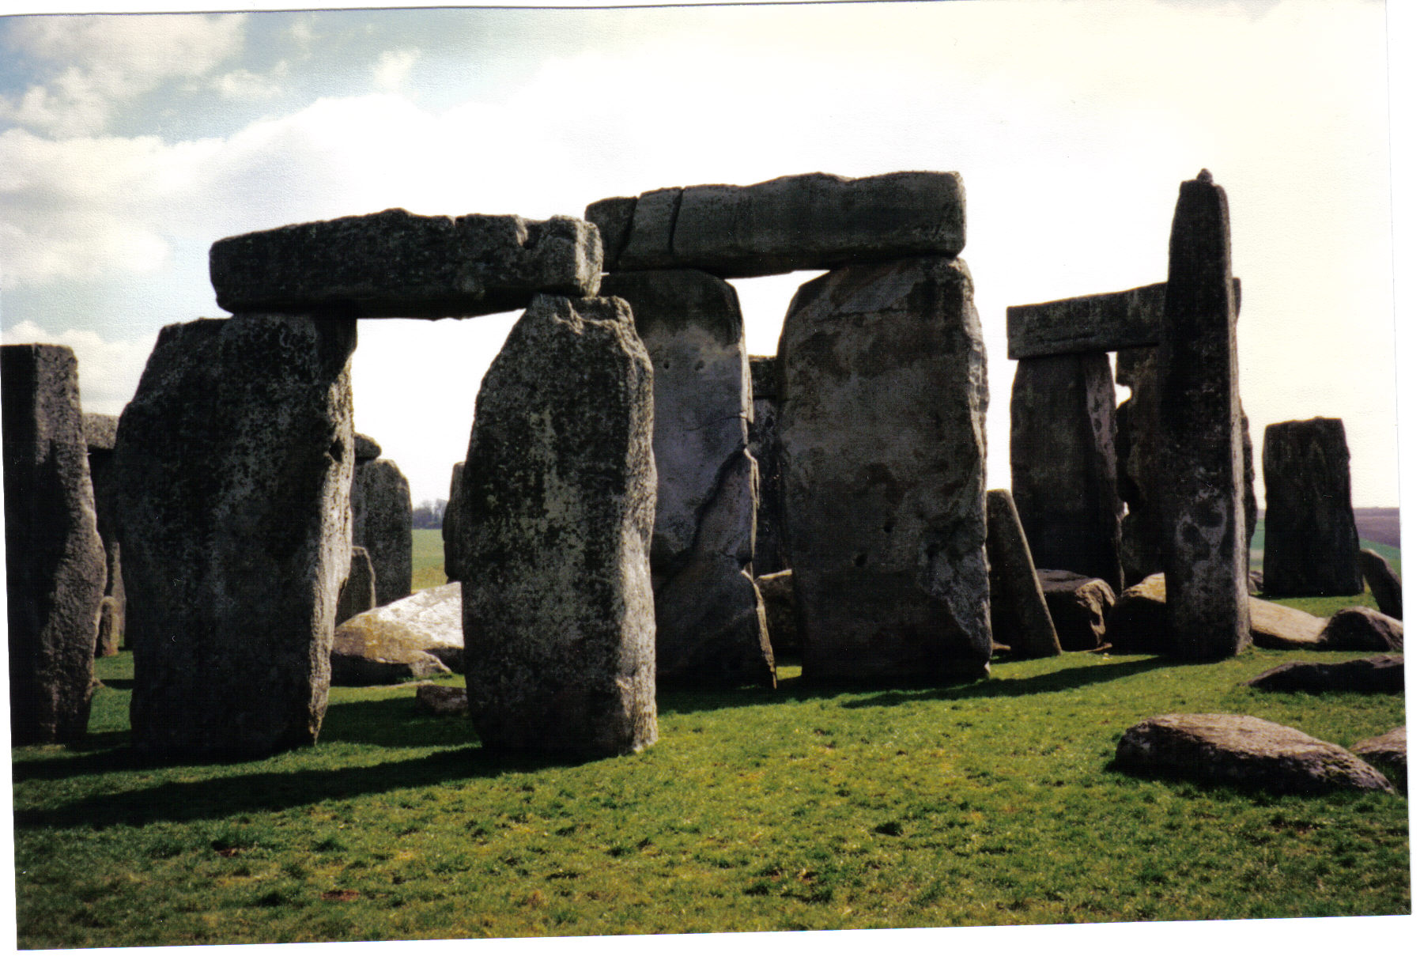

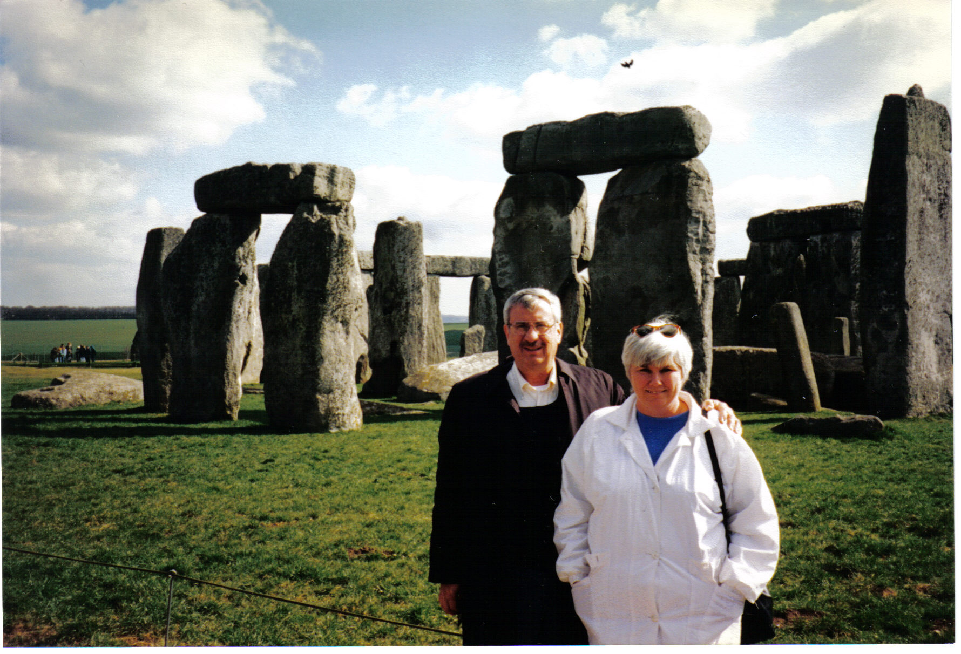

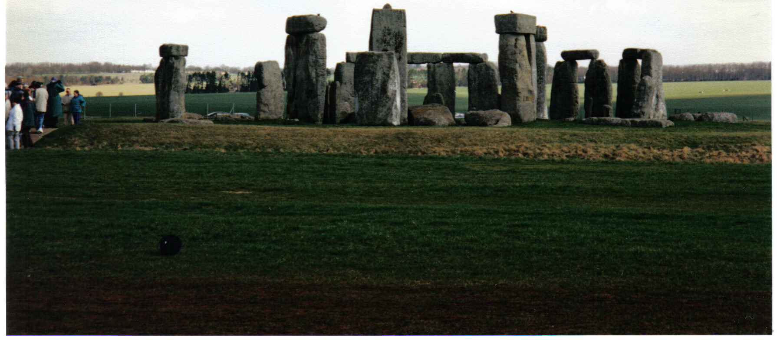

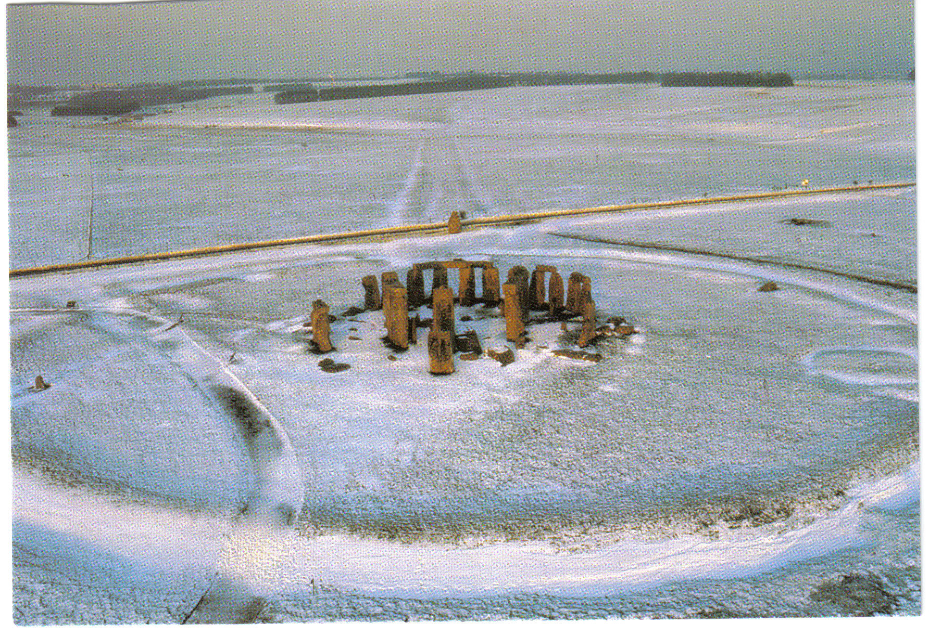

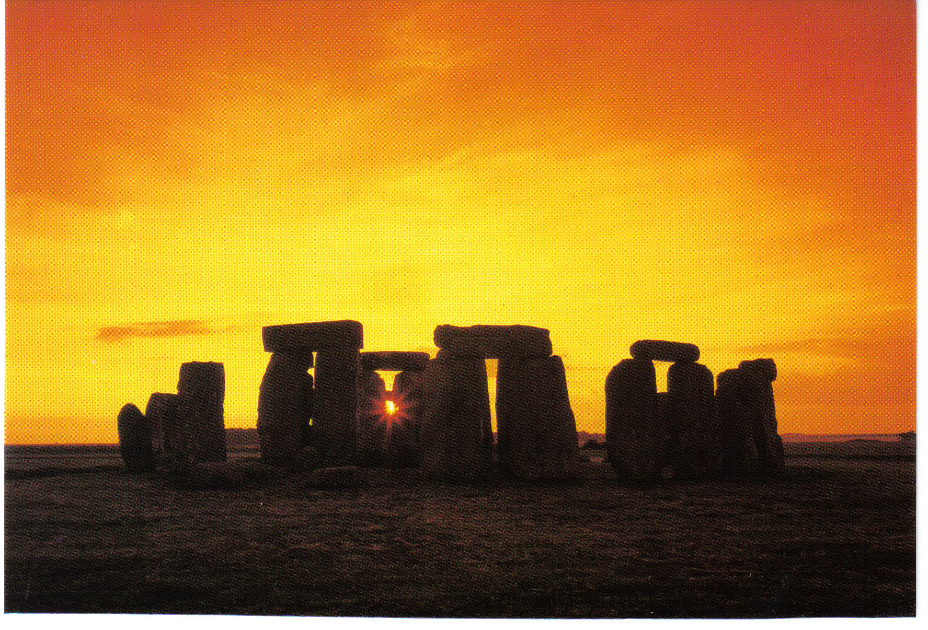

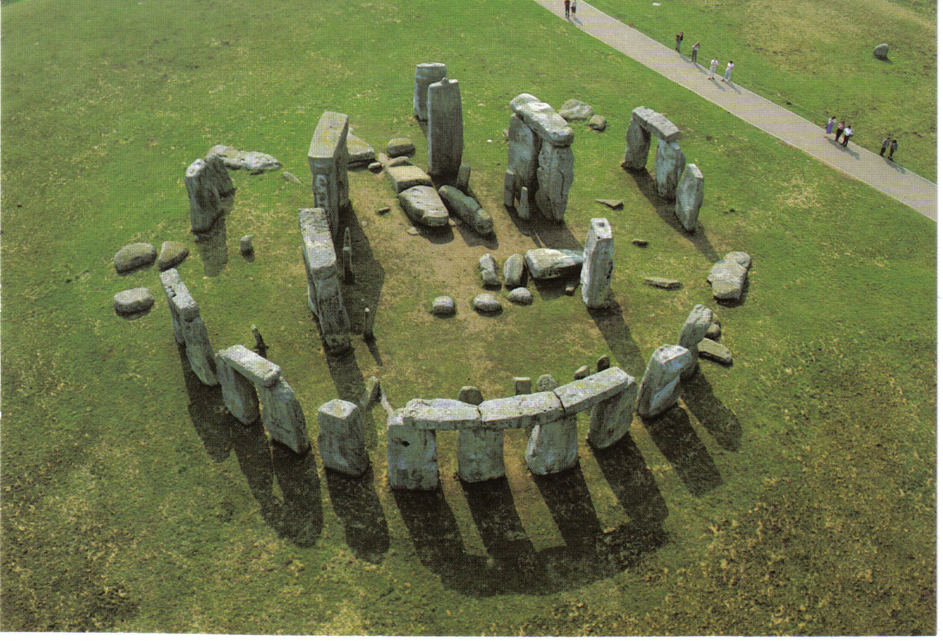

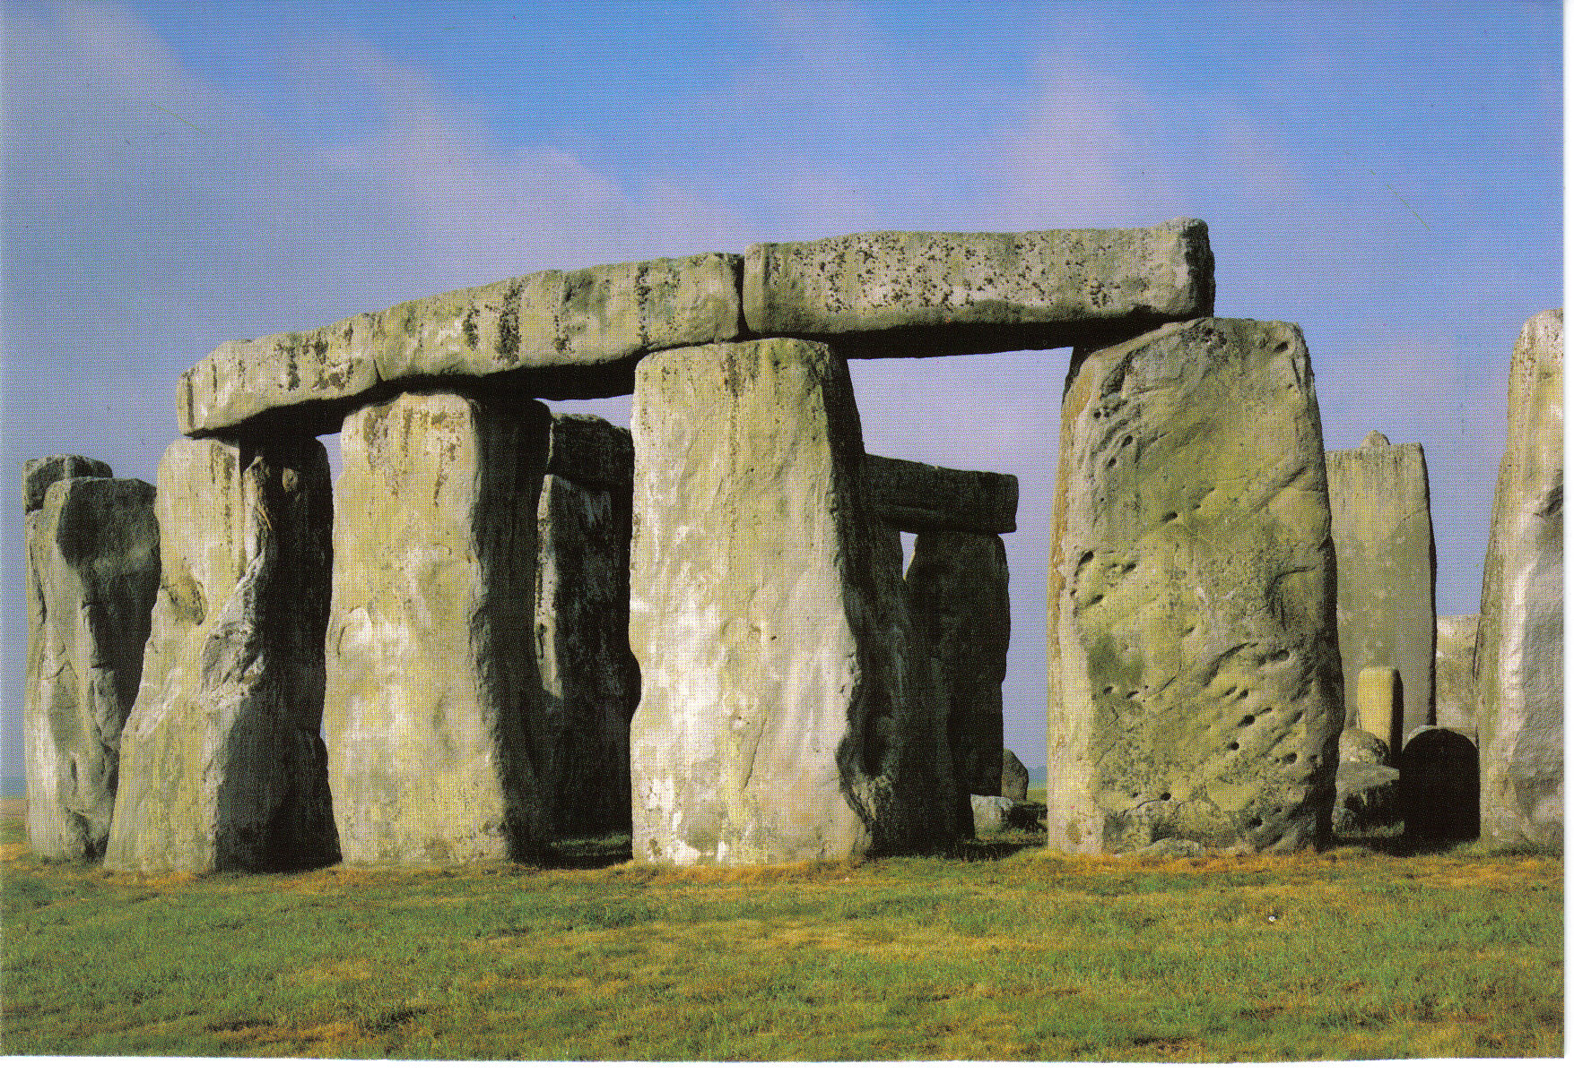

500 B.C.
Abacus. The abacus was probably the original mechanical counting device and its effectiveness has withstood the test of time. It is still used in some parts of the world.

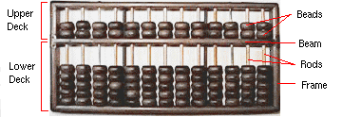

80 B.C.
The earliest known calculator is the geared calculator estimated to date from 80 B.C. is discovered in the oceans off the island of Antikythera, near northwestern Crete. It was discovered in April 1900.

1614
John Napier, a Scottish mathematician and inventor, invents the use of logarithms. His book entitled "Description of the Marvelous Canon of Logarithms" was published this year.

1617
John Napier invents a technique of using numbering rods for multiplication. The rods became known as "Napier's Bones." The user slid the ivory rods
up and down against each other, matching the numbers printed on the rods
to figure multiplication and division problems. Napier’s idea led to the invention of the slide rule in the mid 1600s.
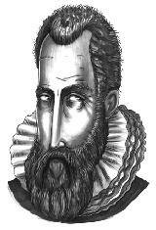
John Napier.
Copyright (c) 1997. Maxfield & Montrose Interactive Inc.

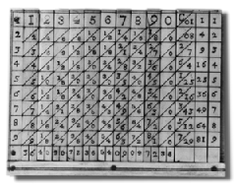

Napier's Bones.
Courtesy of IBM

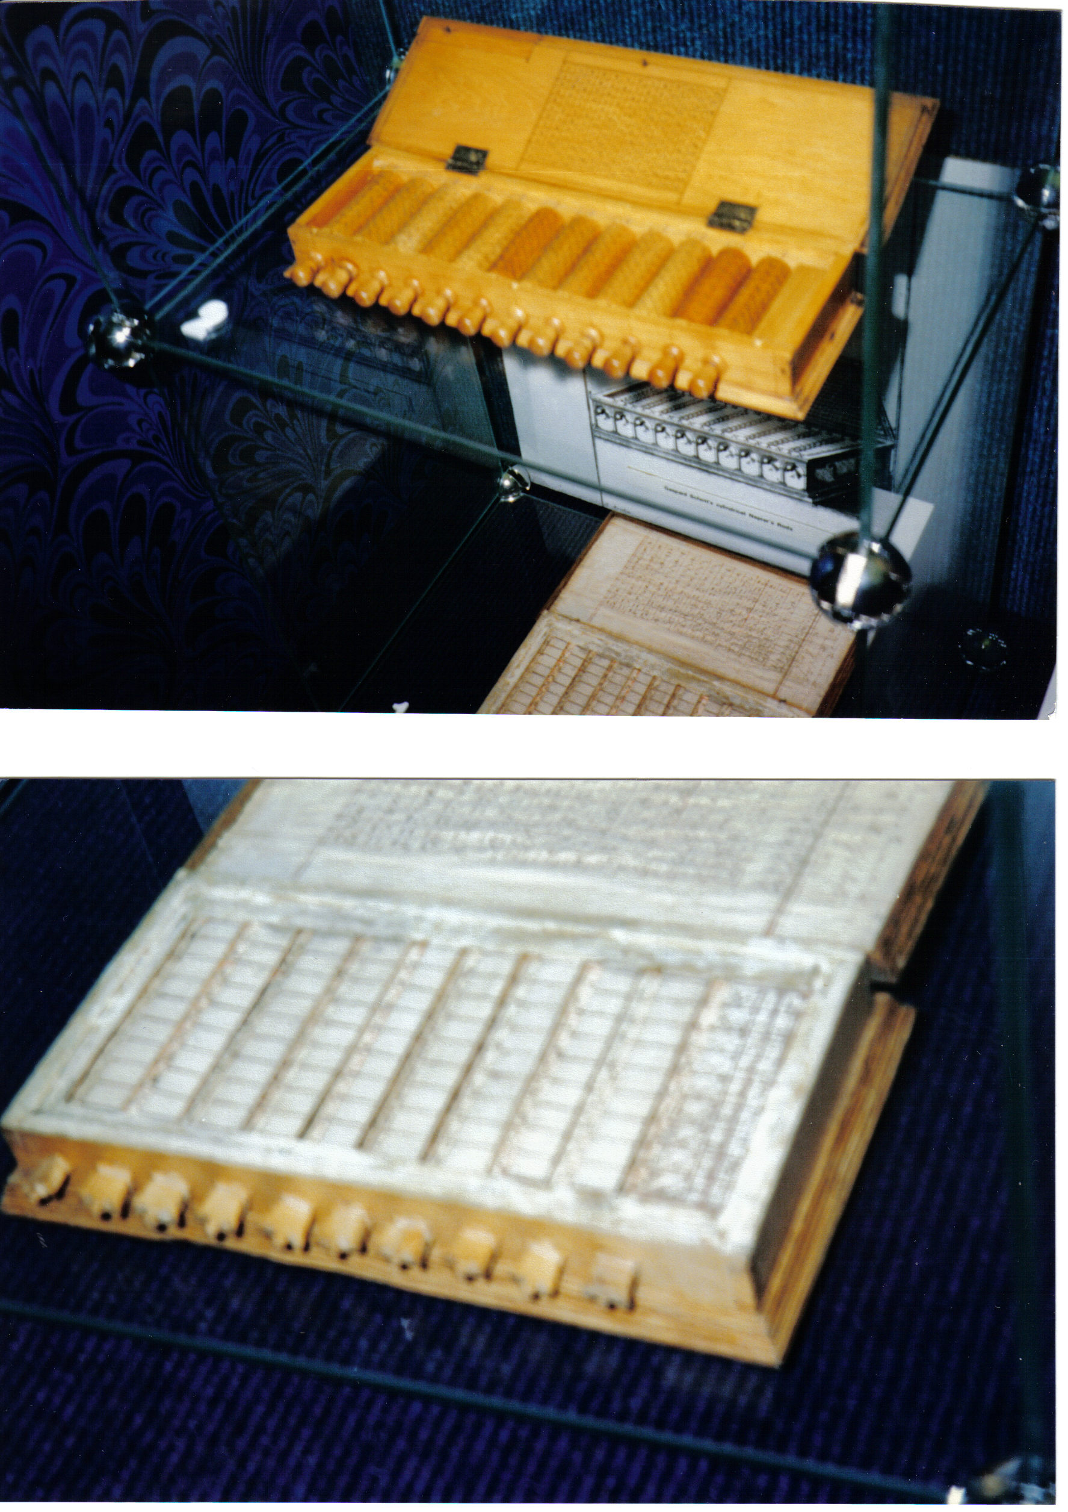

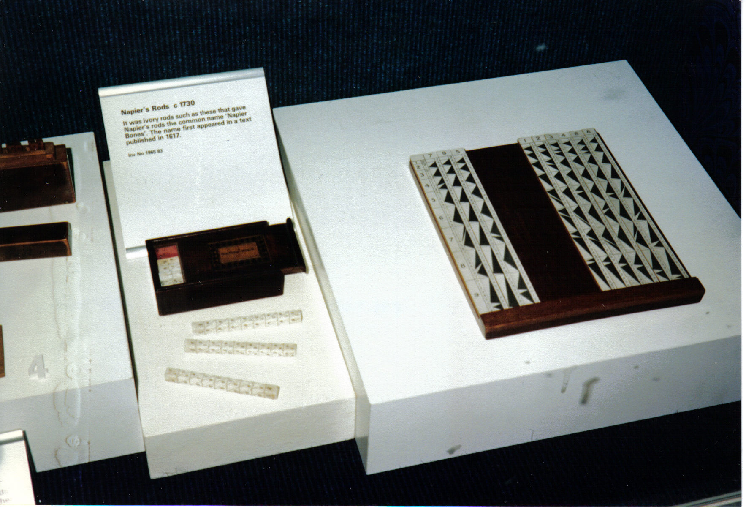

Napier’s Bones (Rods)
The Science Museum, London

1620
Edmund Gunter develops the Gunter Scale, based on Napier's logarithms.

1623
William Schickard builds his "Calculator Clock" which was probably the first mechanical calculator.

1632
The Reverend William Oughtred develops an early slide rule and a circular slide rule.

1642
Blaise Pascal (1623-1662) invents his "Pascaline" calculator. Pascal, a mathematician and philosopher, and his father, a tax official, were compiling tax reports for the French government in Paris. As they agonized over the columns of figures, Pascal decided to build a machine that would do the job much faster and more accurately. His machine could add and subtract. The machine used a series of toothed wheels, which were turned by hand and which could handle numbers up to 999,999.999. Pascal’s device was also called the “numerical calculator” and was one of the world’s first mechanical adding machines.

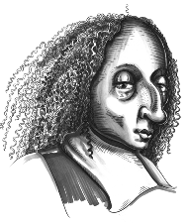
Blaise Pascal.
Copyright (c) 1997. Maxfield & Montrose Interactive Inc


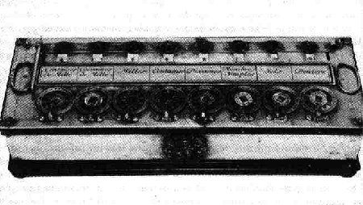
Pascal's Arithmetic Machine.
Courtesy of IBM

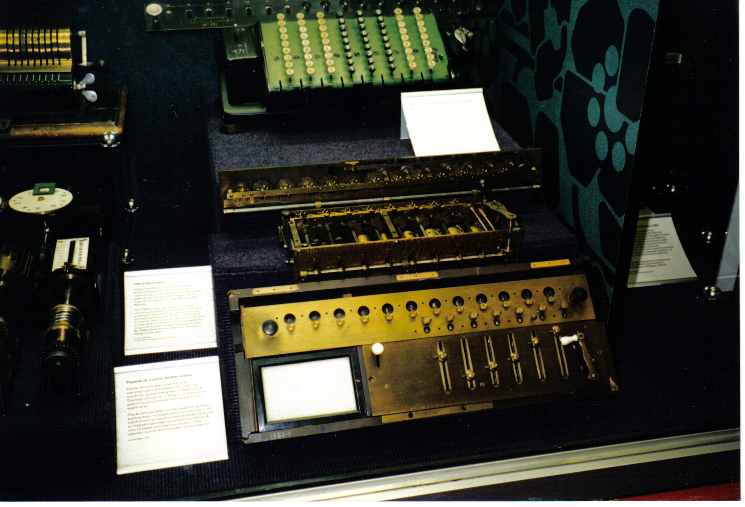

Pascal’s Calculating machine (facsimile)
The Science Museum, London

1663
Sir Samuel Morland builds his trigonometrical calculating machine.

1666
Sir Samuel Morland devices two different types of calculating machines, one of which was similar in concept to Napiers Bones.

1668
Gaspard Schott develops improvements to Napier's Bones in which the numbers were arranged on cylinders which could be rotated. The cylinders were fixed in a box and made setting of the rods for multiplication a faster process.

1678
Rene Grillet, a clockmaker in France, develops an arithmetic machine based on Pascal's device.

1671
Gottfried von Leibniz conceives the "Stepped Reckoner" which used geared wheels, also known as the Leibniz Wheel. His device was not built until about 1694. This machine could add, subtract, multiply, divide and figure square roots. Although the machine did not become widely used, almost every mechanical calculator build during the next 150 years was based on it.

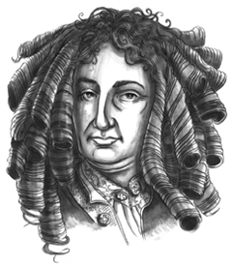

Gottfried von Leibniz.
Copyright (c) 1997. Maxfield & Montrose Interactive Inc.

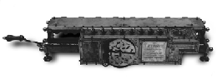
Leibniz's Step Reckoner.
Courtesy of IBM

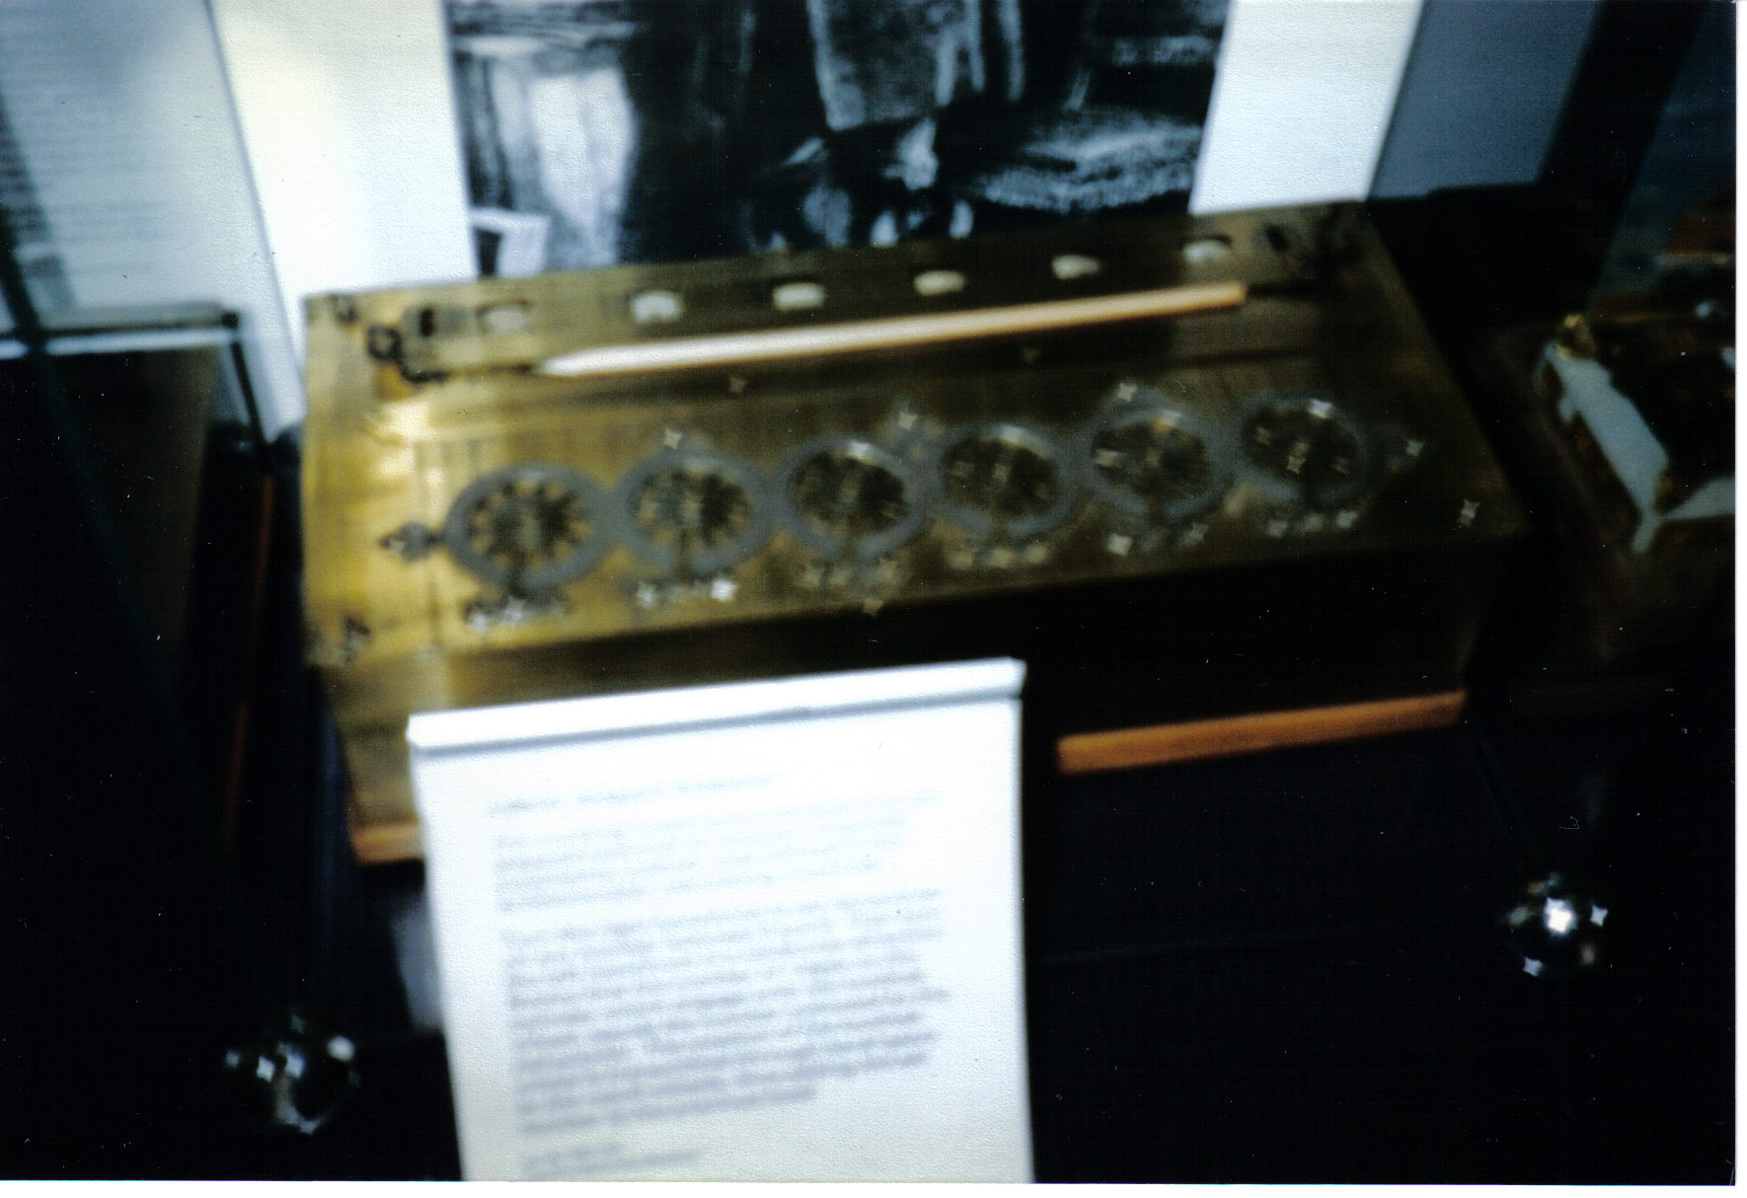
Leibniz’s Stepping Reckoner
The Science Museum, London

1724 The "Leupold Calculator."

1725 The "Lepine Calculator."

1730 The "Boistessandeau Calculator."

1735 Gersten calculator.

1750 The "Pereire Calculator."

1770
Jewna Jacobson, a clockmaker in Minsk, devised a machine to calculate numbers up to five digits.

1774 The "Hahn Calculator."

1775, 1777, 1780
Third Earl Stanhope (Viscount Mahon) develops three different calculators. They were constructed by James Bullock.

1783 The "Muller Calculator."

The technological advances in watchmaking caused many watchmakers to design calculators based on Pascal's original designs. This one is a fine example by J. Sauter, displayed at the Science Museum in London, UK.
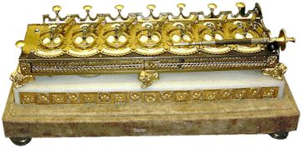

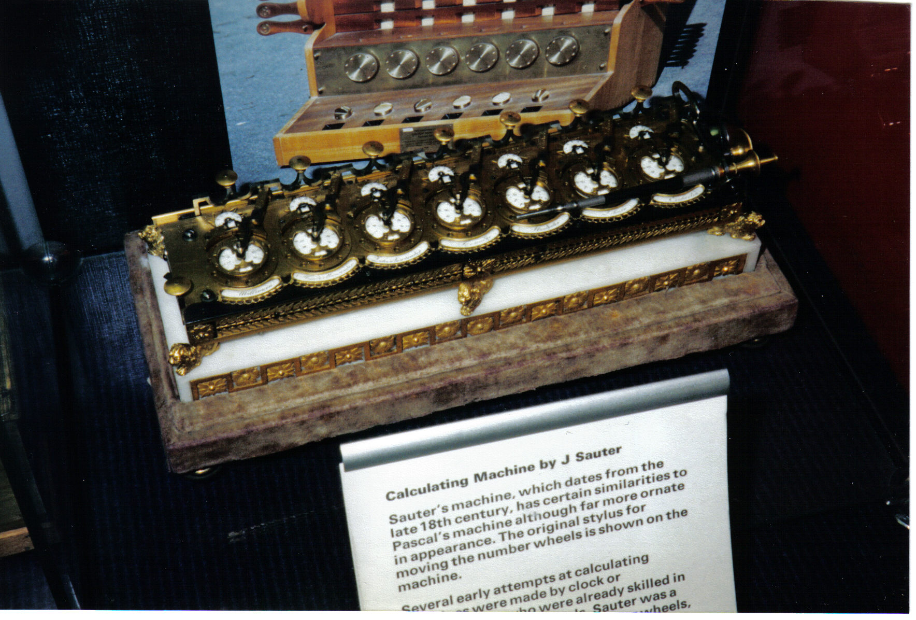
Sauter’s Calculating machine
The Science Museum, London

1805
Jacquard’s Loom. The first signs of automation benefited France’s weaving industry when Joseph-Marie Jacquard built a loom controlled by punched cards. Heavy paper cards linked in a series passed over a set of rods on a loom. The pattern of holes in the cards determined which rods were engaged, thereby adjusting the color and pattern of the product. Prior to Jacquard’s invention, a loom operator adjusted the loom settings by hand before each glide of the shuttle, a tedious and time-consuming job. Jacquard’s loom emphasized three concepts important in computer theory. One was the information could be coded on punched cards. A second was that cards could be linked in a series of instructions -- essentially a program -- allowing a machine to do work without human intervention. A third concept was that suvh programs could automate jobs.

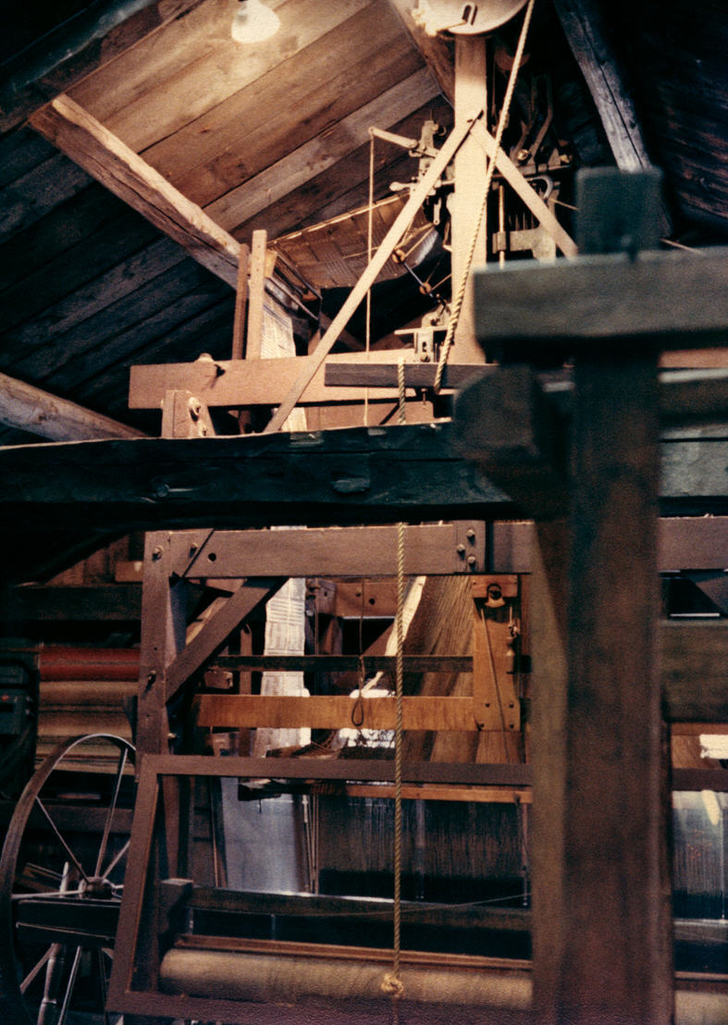
Jacquard’s Loom (Reproduction)
This working Jacquard Loom is at the Shelburn Museum near Burlington, Vermont

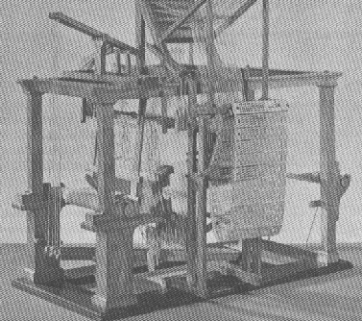

Jacquard’s Loom

1820
Charles Xavier Thomas de Colmar develops the Arithmometer adding device.

1833
Charles Babbage (1791-1871) builds his "Difference Engine."
Charles Babbage was born in London, England. He entered Cambridge University in 1810, and was recognized for his exceptional mathematical abilities. In 1828, he was appointed Lucasian Professor at the university, a position which Sir Isaac Newton once held. In around 1833, Babbage developed the "Difference Engine" concept but lacked the funding and support to build the device.

Babbage worked on the concepts for an "Analytical Engine," which were described in writings by Lady Augusta Ada, Countess of Lovelace, daughter of Lord Byron, in 1842. Babbage discussed the concept of using punched cards to control the operation of his calculating machine, but he was never able to build a full working model. General L. F. Menebrea wrote about Charles Baggage's machine designs in 1841.

Babbage’s ideas embodied five key concepts of modern computers:
1. Input device
2. Processor or number calculator
3. Control unit to direct the task to be performed and the sequence of
calculations.
4. Storage place to hold number waiting to be processed
5. Output device

Although Babbage died before he could construct his machine, his son built a model that worked from Babbage’s notes and drawings. Because of the ideas he introduced, Babbage is known as the Father of Computing.

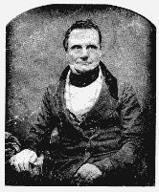

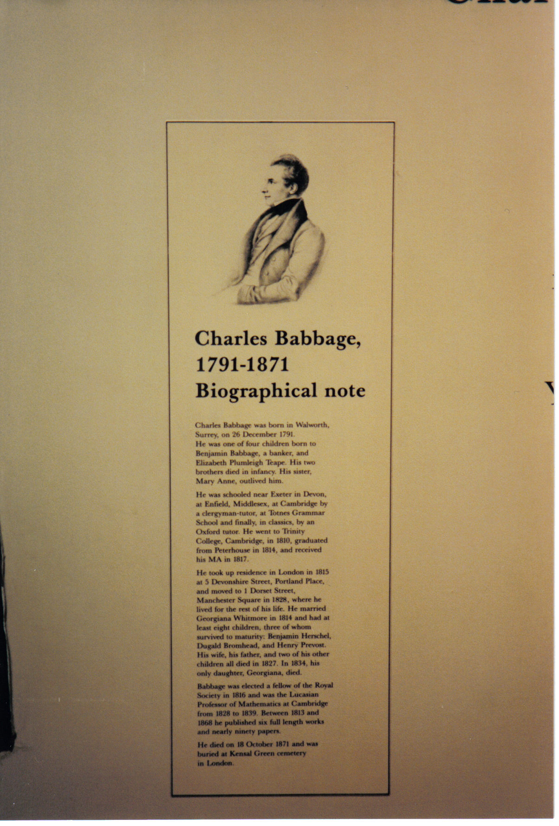
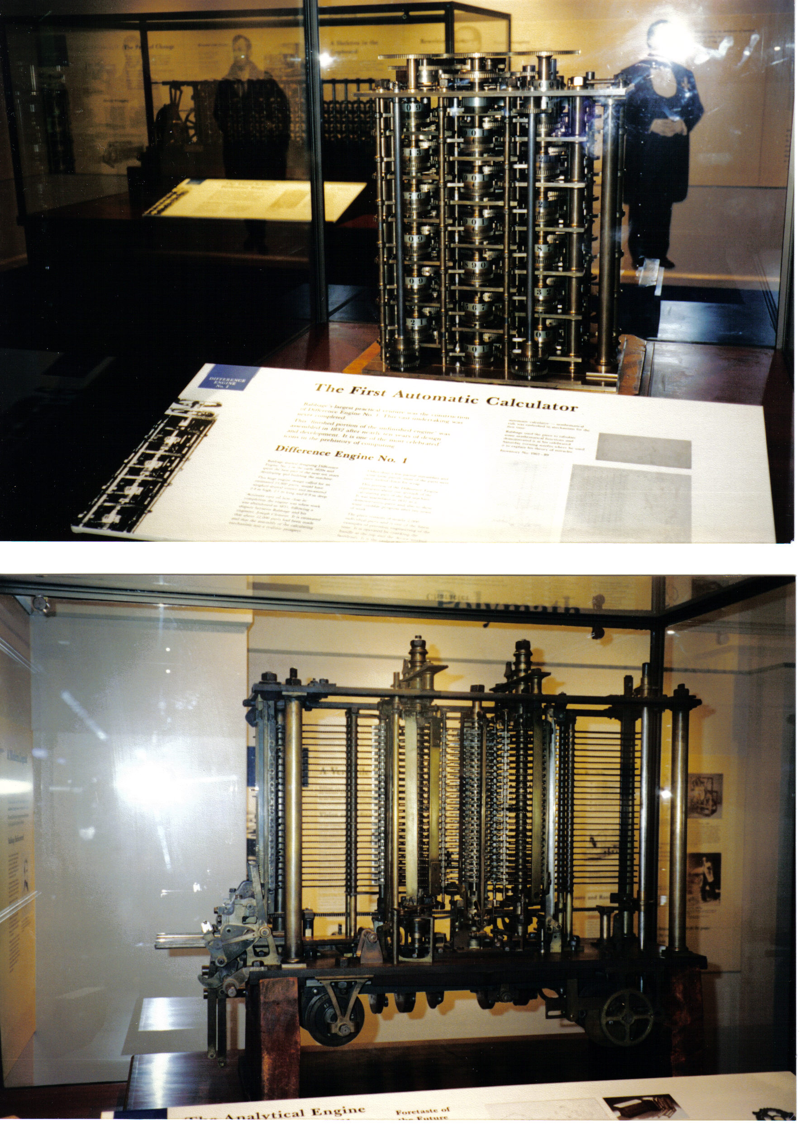
Babbage’s Analytical Engine
The Science Museum, London

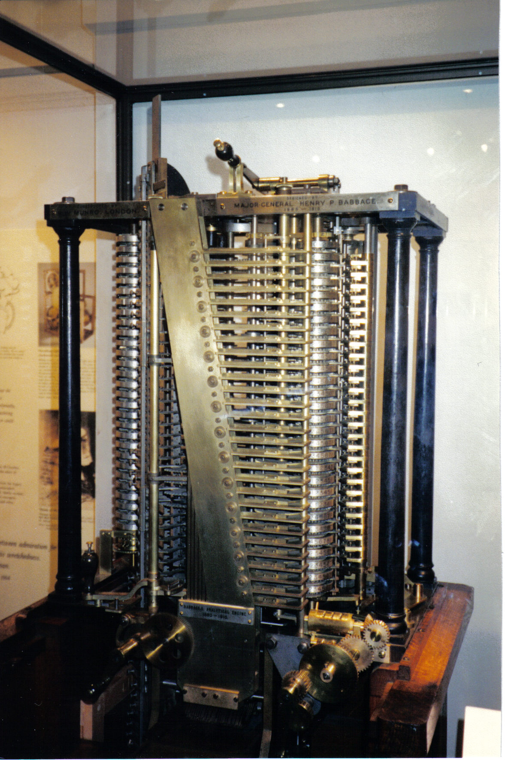
Son of Babbage: Machine built by the son of Charles Babbage
The Science Museum, London

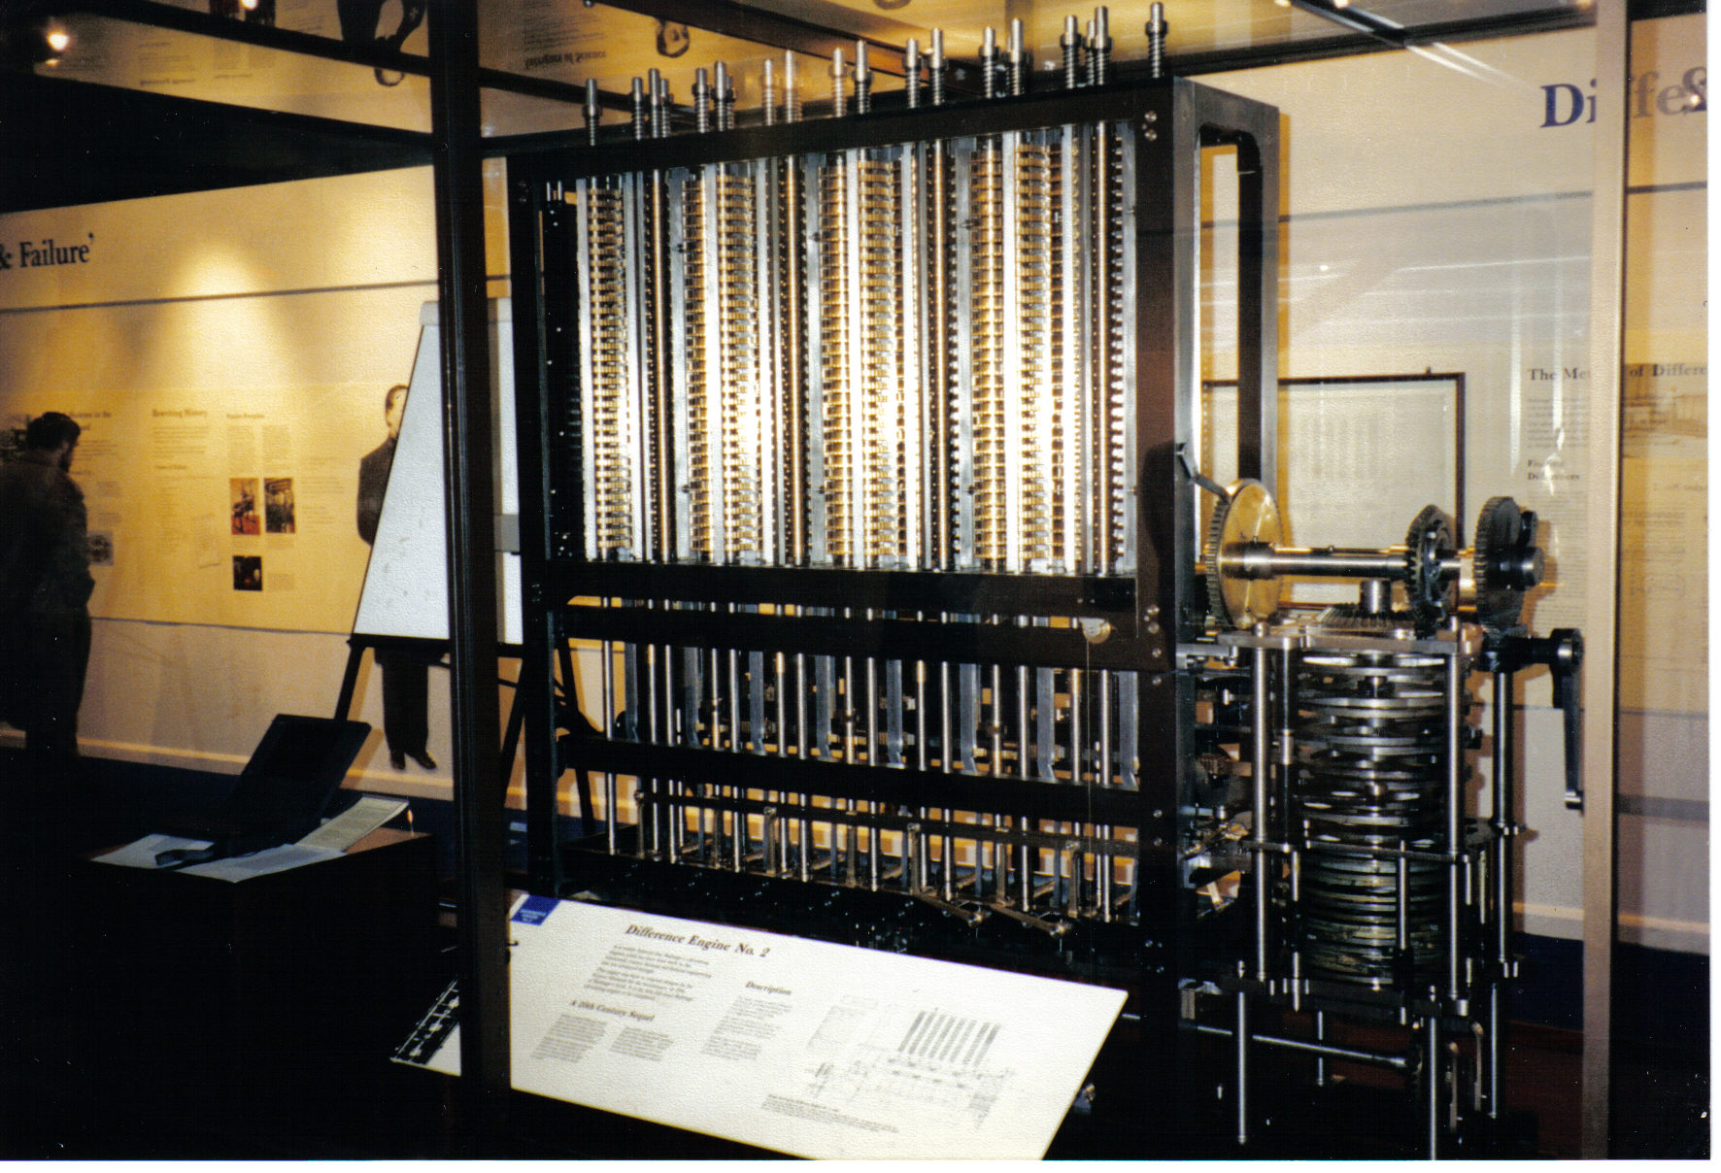
Full scale Analytical Engine built in 1991 according to Babbage’s
original specifications. The Science Museum, London

Augusta Ada Byron
Countess of Lovelace

Augusta Ada was the daughter of the poet, Lord Byron. She was a bright mathematician who was introduced to Charles Babbage in 1833. Ada Byron was fascinated by a demonstration of Babbage's Difference Engine which Babbage had arranged. Babbage found that Ada understood and could explain the workings of his machine better than anyone else.

Babbage later toured Europe giving lectures on his more advanced concept, the Analytical Engine, a machine which he never fully constructed. Extensive notes were taken of some of these lectures in French. Ada translated the French notes into English and added a lengthy addendum.

At Babbage's request, she published her notes. She had a unique grasp of the concepts of programming subroutines, loops and jumps. She is often referred to as the first programmer. She was instrumental in clarifying and preserving information on Charles Babbage and his work. When Augusta was 19, she married the wealthy Lord King, Baron of Lovelace. Her husband had some knowledge of mathematics, but it was Ada who urged him to provide funding to Babbage when his government funding ceased. Ada also had an interest in gambling, and attempted to apply some of Babbage's technology to that end, but without great success.

In recognition of her contributions to the field of programming theory, the U.S. Department of Defense named their programming language for reducing software development and maintenance costs "ADA" in her honor in the mid 1970's.
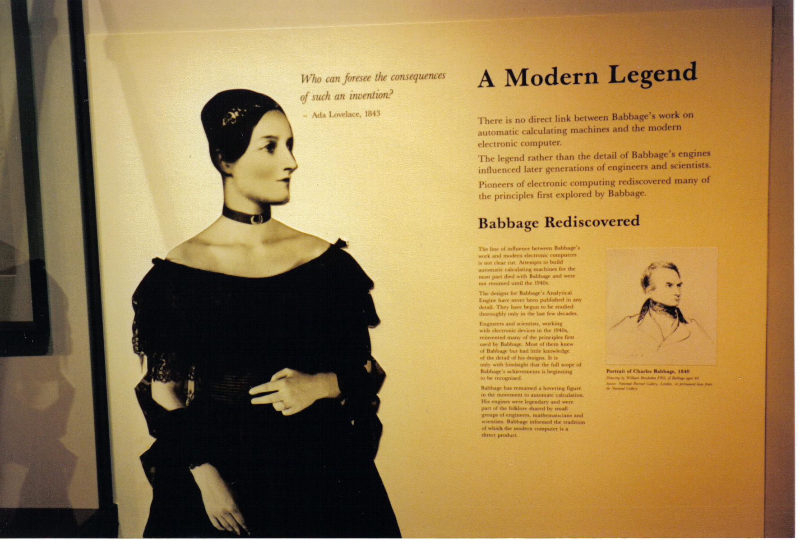
Picture of Ada. The Science Museum, London
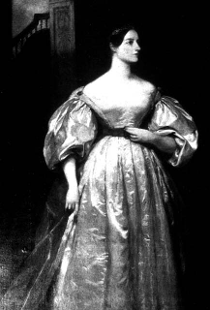

1843
Pehr Georg Scheutz and his son build a Difference Engine based on some of
Babbage's principles.

1850
D. D. Parmalee obtains the first U.S. patent for a key-driven adding machine.

1850
Amedee Mannheim creates a slide rule with an improved scale arrangement, which becomes a popular feature in slide rules in later years. His design becomes known as the "Mannheim Slide Rule."

1872
E. D. Barbour incorporated a printing device into a calculator.

1872
Frank Baldwin designs an early calculator. He obtained a patent in 1875, for device with spring loaded pins, which was a major advancement at the time. This device was forerunner of the Monroe Calculator.

1874
Swedish engineer W. T. Odhner invents the "Odhner" calculator based on the pinwheel principle. His successful design became the model for many other successful calculators which followed, such as the Friden, Brunsviga, and Marchant. He produced the Odhner Model 1 Arithmometer (circa 1886). He obtained a patent on his machine in 1891.

1876
Lord Kelvin publishes a paper on a mechanical differential analyzer.

1878
George Fuller, Professor of Engineering, Queen's College at Belfast, received a patent for his slide rule (British Patent No. 1044).

1880
Herman Hollerith develops punched-card tabulating machines.

Herman Hollerith

(1860-1929)

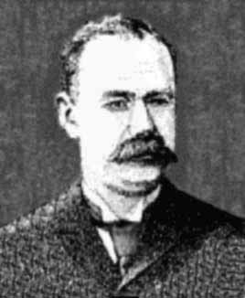

Hollerith, son of a German immigrant, became an American inventor and a brilliant engineer. He graduated from Colombia College and joined the U.S. Census office in 1860 as a statistician. Hollerith began experimenting with ideas to make census taking less time consuming. Hollerith took a teaching job at MIT in 1882 which gave him more time for his experiments. In 1883, Hollerith was appointed assistant examiner in the U.S. Patent Office.

He held this position until March 31, 1884.

He built a battery operated machine to tabulate death records for the government officials in Baltimore in 1887. His machine successfully completed in several days, what it normally took humans three weeks of work to accomplish. In 1889, he used another machine to tabulate statistics for the Surgeon General of the Army. He entered his punched-card tabulating machine in the competition for a contract with the U.S. Census Office for tabulating the 1890 census.

Hollerith's machine finished in record time, far faster than his competitors. Hollerith's machine allowed the 1890 census to be completed in six weeks instead of several years.

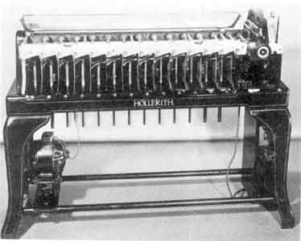
Hollerith’s Machine

Hollerith continued to make improvements in his machines, selling them to businesses for data processing needs.

On December 3, 1886, Hollerith organized the Tabulating Machine Company (TMC) with an initial capitalization of $100,000, made up of 1,000 shares of common stock with a par value of $100. Hollerith became general manager and held 502 shares. In 1911, he sold his company. By then, hundreds of his machines had been installed by business.

In 1894, Herman Hollerith patents a punched card system which utilized pneumatic pressure rather than electricity and air tubes rather than electrical wires. Although never built, it reflected his continued interest and development in the punched card systems and his application of knowledge from his railroad breaking systems patents. The Tabulating Machine Company continued to grow and merged with other companies, and in 1924,
formed the International Business Machines Corporation (IBM).

Hollerith achieved 38 patents during his lifetime, and achieved financial success, but he never invested any additional monies in his grandchild, IBM.

1880
Ramon Verea invented the first calculator capable of multiplying directly rather than by repeated addition.

1881
Edwin Thacher patents his slide rule (patent No. 249,117).

1885
William Seward Burroughs develops the Burroughs Adding Machine.

1885
Dorr Eugene Felt develops the "Marconi Box" adding machine. In 1887, he patented his machine called the "Comptometer", one of the first practical adding machines. (See Dorr Eugene Felt). Comptometer became very successful in the 1920's and 1930's. The company was called Felt & Tarrant.

1886
American Arithmometer Company of Saint Louis, Missouri, produces the "American Arithmometer" machine. (In 1905, American Arithmometer changes its name to the Burroughs Adding Machine Company.

1887
Leon Bollee develops a calculator capable of performing multiplication directly.

1888
William S. Burroughs develops the first registering accounting machine.

1892
William S. Burroughs develops a 90-key adding machine with a capacity of up to nine decimal digits.

1892
Otto Stigler patents "The Millionaire" a relatively fast mechanical arithmetic machine.

1908
David and Oscar Sundstrand invent the first 10-Key adding machine. They market it in 1914.

1922
The Marchant Brothers marketed first electrically operated and cleared calculator.

1926
Derrick Henry Lehmer, an American mathematician, developed a mechanical
computing device that could determine large prime numbers. Lehmer's
"Number-Sieve" could analyze 3,000 numbers per second to determine whether or not they were prime.

1926
Stuart Dodd, a researcher at Princeton University, built a machine to automatically calculate correlations. Later versions of his machine were known as Dodd Correlators.

1930
Vannevar Bush constructs a differential analyzer at MIT.

1935
Douglas Hartree constructs a copy of the Bush differential analyzer at Manchester University.

1936-46
Konrad Zuse of Germany conducts his early research and designs and builds early computers. Zuse built some of the very first digital computing devices, his "Z" machines.

1939
First remotely operational, electromagnetic relay calculator (Bell Labs Model 1, Stibitz Complex Calculator) was developed by George Stibitz and Samuel B. Williams at Bell Labs

1938-41
First functional, programmable, electromechanical computer, Z3, developed by Konrad Zuse of Germany.
1937-1942
John Vincent Atanasoff
(1903-1995)

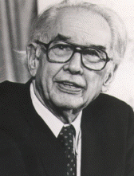
First functioning prototype electronic digital computer, the Atanasoff-Berry Computer ("ABC"), developed by John Vincent Atanasoff and Clifford Berry.

John V. Atanasoff received his Masters Degree from Iowa State College (now Iowa State University) in 1926, and his Ph.D. from the University of Wisconsin in 1930. He served as an instructor at Iowa State College (1926-1929), as an instructor at University of Wisconsin (1929-1930), and became an associate professor at Iowa State in 1930. Atanasoff developed
the first logic circuit with vacuum tubes.

In 1939, he worked with Clifford Berry, a graduate student, on an electronic digital computer, he later called the "Atanasoff-Berry Computer" (ABC), at Iowa State University. The ABC was the first electronic digital computer. It used vacuum tubes and capacitors arranged on a drum, and utilized punched cards. The ABC was completed in 1942, which was several years before the more famous early digital computer, the ENIAC, was completed by J. Presper Eckert and John Mauchly. (Almost a year earlier, however, Dr. Konrad Zuse of Germany, developed the first digital, general purpose computer which used relays, rather than vacuum tubes, the Z-3.)

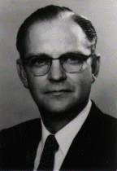

From 1942 to 1949, John Atanasoff was Chief of Acoustics Division, U.S. Naval Ordnance Laboratory ("NOL") in Washington, D.C. From 1949 to 1950 he served as Chief Scientist at the Army Field Forces, Fort Monroe, Virginia. From 1950-1951 he was Director of the Navy Fuze Program at the NOL.

From 1952 to 1956 he served as president of the Ordnance Engineering
Corporation, Frederick, Maryland. From 1956 to 1961 he was Vice President of Aerojet General Corporation and Manager of the Atlantic Division. In 1961 he became president of Cybernetics, Inc., in Frederick, Maryland.

In a law suit which followed years later, between Honeywell and Sperry, Atanasoff was acknowledged as the inventor of the electronic digital computer, even though he never successfully obtained a patent on it.

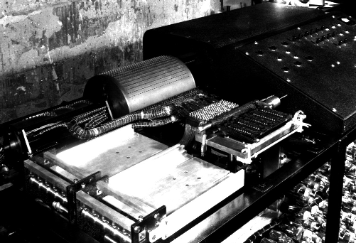

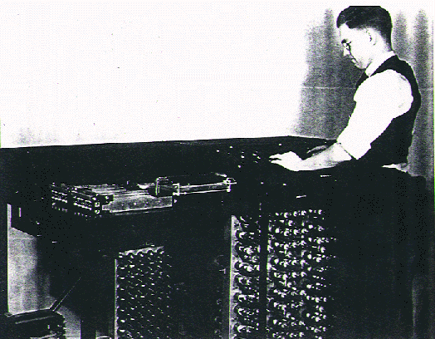

Berry and the ABC Computer

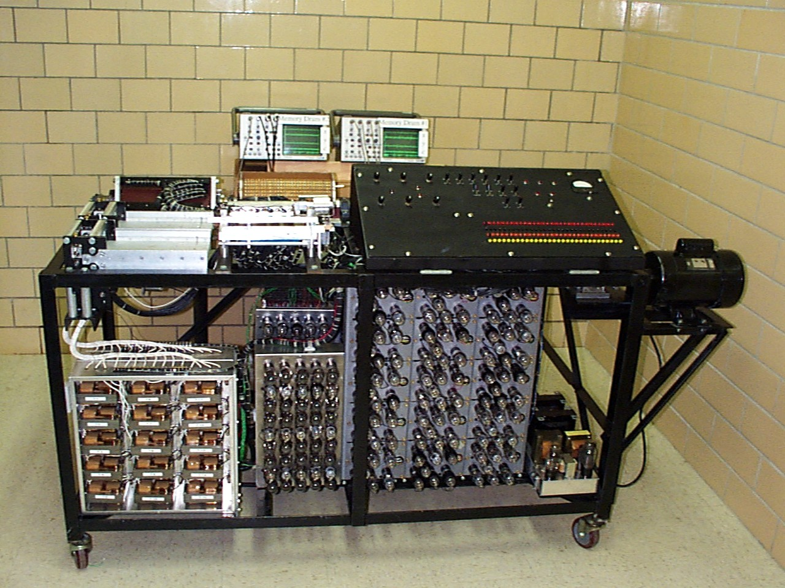
ABC Computer (Rebuilt)

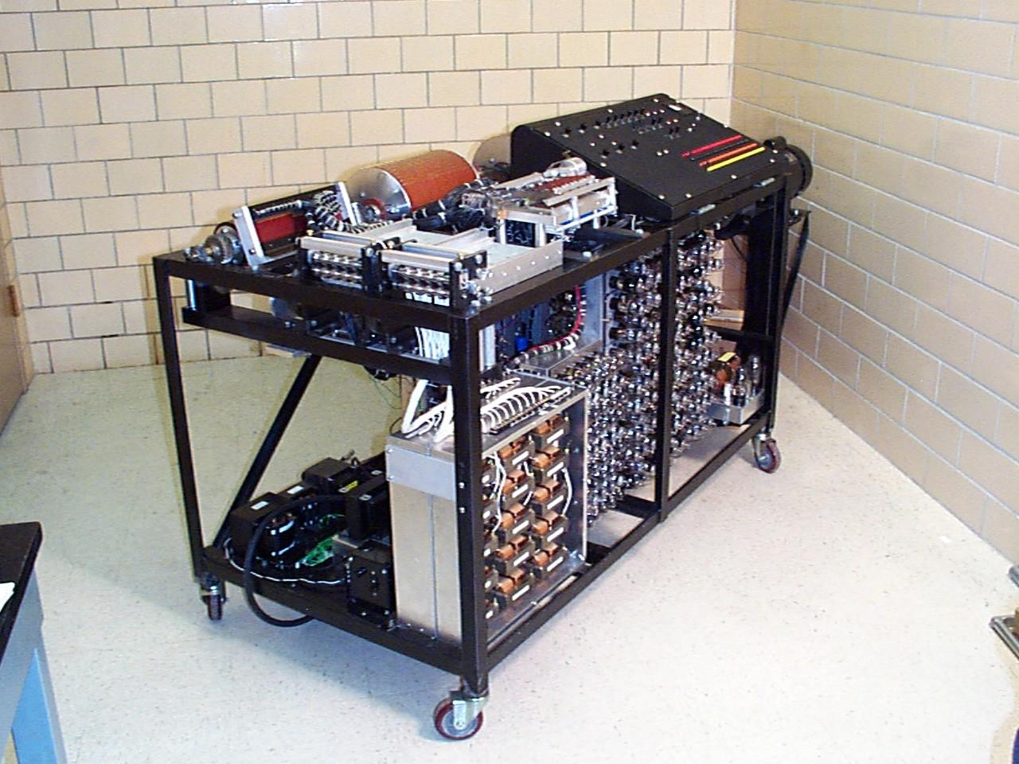
Another view: ABC Computer (Rebuilt)

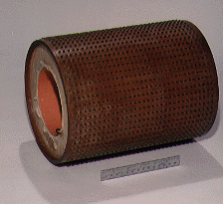
This drum holds 30 numbers of 50 bits each. (Two of the columns are spares). They are operated on in parallel. It is the first use of the idea we now call "DRAM" -- use of capacitors to store 0s and 1s, refreshing their state periodically.
It is the only surviving fragment of the original ABC built in 1939.
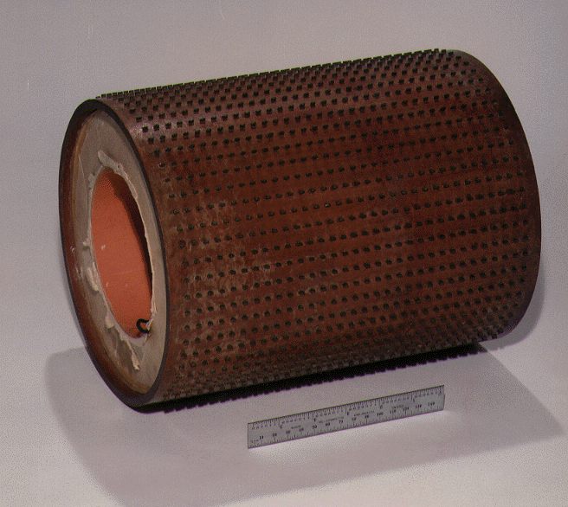

1939-43
Howard Aiken and IBM construct the Harvard Mark I (IBM Automatic Sequence Controlled Calculator "ASCC").

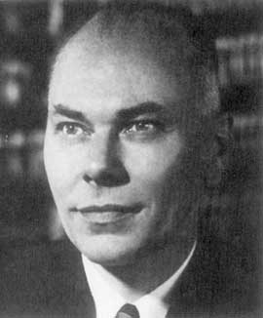

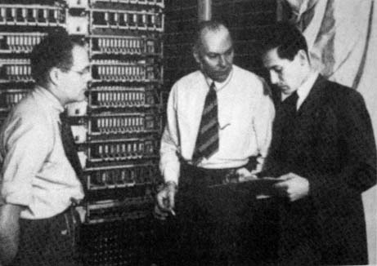

Harvard Mark I

IBM Automatic Sequence Controlled Calculator (ASCC)

The Harvard Mark I was also known as the IBM Automatic Sequence Controlled Calculator (ASCC).) Members of the development team, headed by Howard Aiken, included IBM engineers Claire D. Lake, Francis E. Hamilton, and Benjamin M. Durfee.

The Harvard Mark I was 51 feet long, 8 feet high, and weighed over 5 tons. This giant calculator contained 500 miles of wire, 3,000,000 wire connections, 3,500 multipole relays with 35,000 contacts, 2,225 counters, 1,464 ten-pole switches, and tiers of 72 adding machines. It was used at the Harvard Computation Laboratory.

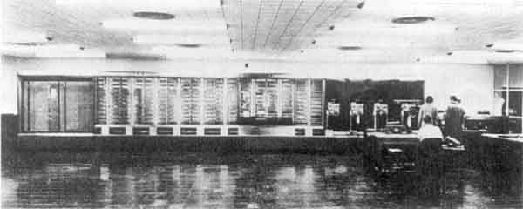

The Harvard Mark I was a generalized machine designed to do a wide variety of mathematical problems. It was designed to address such problems as
(1) computation and tabulation of functions,
(2) evaluation of integrals,
(3) solution of ordinary differential equations,
(4) solution of simultaneous linear algebraic equations,
(5) Harmonic analysis, and
(6) statistical analysis.

It was primarily used for defense problem solving, firing tables, logistics, mathematical simulations and problems relating to atomic bombs. In May of 1944, the Harvard Mark I was moved from IBM Edicott Labs to Harvard University.

It remained in use until 1959. The ASCC was first calculator to have a built-in stored program. It was one of the first computers to use registers.

Grace Murray Hopper

(1906-1990)

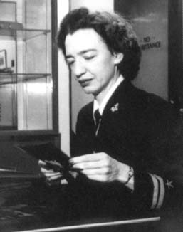

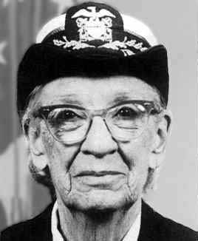

Grace Hopper was born in New York and received her B.A. in Physics and Mathematics from Vassar College in 1928. She attended Yale University where she received her MA in 1930 and her Ph.D. in 1934. She achieved the grade of Navy Lieutenant, J.G. in 1944, and went to work on the Bureau of Ordnance's Computation Project at Harvard University.

This project, headed by Howard Aiken, was developing the Harvard Mark I, also known as the IBM Automatic Sequence Controlled Calculator. Grace Hopper functioned as the third member in a team of three programmers. In 1949, she joined the newly created Eckert-Mauchly Computer Corporation. Eckert-Mauchly were developing the BINAC binary computer, which Grace Hopper programmed in octal. At this time, Grace Hopper became aware of John Mauchly's work on "Short Order Code." Mauchly developed "Short
Order Code" for the BINAC in 1949, and it was later revised for use on the UNIVAC in 1952.

Ms. Hopper also developed A-O, the first compiler (1952); the A-2, the first compiler to handle symbolic manipulation (1953), and Flow-Matic (1957). Grace Hopper is known for her significant contribution to the field of computer languages. Her design of the language "Flow-Matic" was very influential in the later development of a common business oriented language (COBOL).

COBOL is still in use today, and is probably the most widespread computer language of all time. Grace Hopper remained part of the Eckert-Mauchly Computer Company even after its acquisition by Remington Rand and later Sperry Rand. She retired from the UNIVAC Division of Sperry Rand in 1971. In 1971, she was appointed Professorial Lecturer in Management Science at the George Washington University, were she served until 1978.

From 1973, she also held the position of Adjunct Professor of Electrical Engineering at the Moore School of Engineering at the University of Pennsylvania. In 1966 she had retired from the U.S. Navy, but was recalled to active duty in 1967. In 1973, she was also promoted to the rank of Captain. In 1983, she was promoted again, this time to Commodore.

In 1985, she became Rear Admiral and remained on active duty with the Naval Data Automation Command until 1986, when her name was returned to the retired list. During her long career, Grace Hopper published over 50 papers on computer software and programming languages and received over seventy- five different awards and honorary degrees. Among these are:

Fellow-
- American Association for the Advancement of Science (1963)

Data Processing Management Association -
- "Man-of-the-Year" Award (1969)

American Federation of Information Processing Societies -
- Harry Goode Memorial Award (1970)

Distinguished Fellow -
- British Computer Society (1973)

U.S. Navy Meritorious Service Award (1980)

IEEE Computer Pioneer Award (1983)

Association of Computing Machinery -
- Distinguished Service Award (1983)

Lifetime Achievement Award -

- Federation of Govt. Information Processing Councils (1986)

1946
The Electronic Numerical Integrator and Calculator (ENIAC) was designed by J. Presper Eckert and John W. Mauchly. ENIAC contained 19,000 vacuum tubes, 70,000 resistors, and 5 million soldered joints. It weighed 30 tons and occupied 1500 square feet. With this device, computers and associated equipment became known as hardware. The ENIAC was able to perform 5,000 additions per second and use so much power it caused the lights to dim in one section of Philadelphia. The problem with the ENIAC was that it could not save instructions. The user had to re-enter the instructions each time.

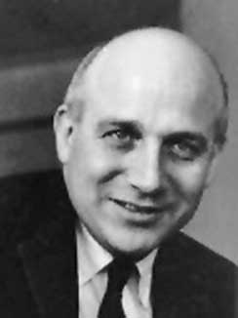
J. Presper Eckert

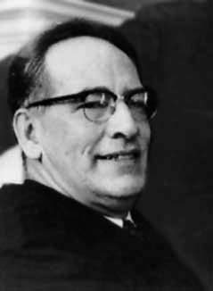
John Mauchly

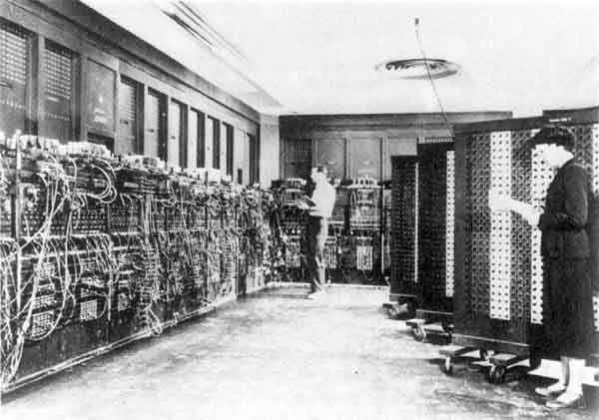
ENIAC

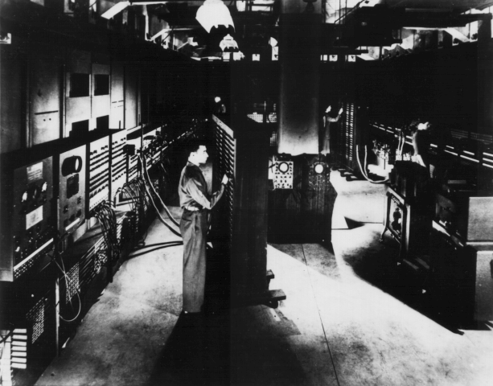
ENIAC

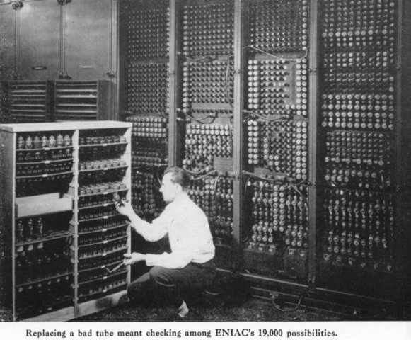

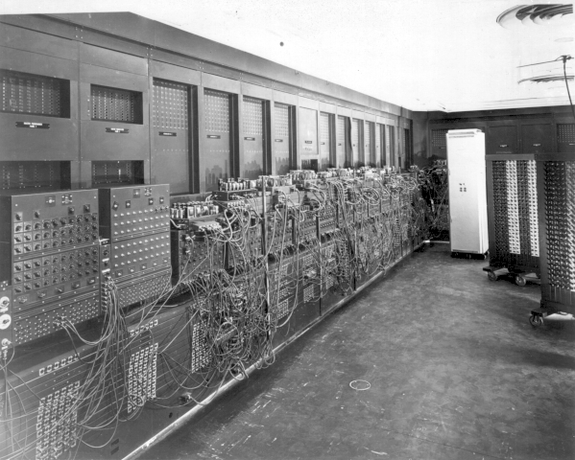
ENIAC

1945
John Von Neumann responded to the problems of the ENIAC by proposing the EDVAC (Electronic Discrete Variable Automatic Computer) which utilized the stored program concept. These types of machines even today are called von Neumann machines.

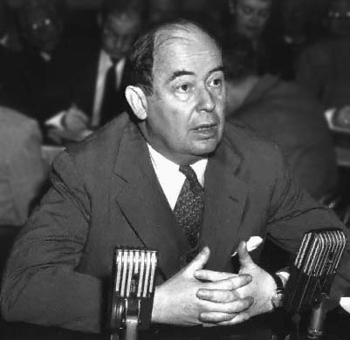
John Von Neumann

1951
The first computer sold was the UNIVAC I developed by Mauchly and Eckert as a direct result of the ENIAC and EDVAC. They approached Remington Rand (today Sperry Corporation) for financing. They bought Mauchly and Eckert’s company and becan the computer industry. The first computer was sold to the Census Bureau, replacing their IBM equipment.

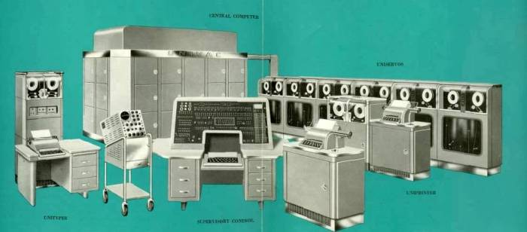
The UNIVAC 1 SYSTEM (1951).

1954
The first computer sold to private industry (UNIVAC I) was sold to General Electric’s Appliance Park in Louisville, KY.

1959-61
First commercially available integrated circuit, developed by Fairchild Corporation

1960's
The "Anita," an electronic calculating machine is introduced.

1964
Texas Instruments began development of its "Cal Tech" hand-held calculator. The Cal Tech was built around TI's own integrated circuits and featured four functions and a thermal paper tape readout. It was completed in March 1967.

1964
Victor Business Machines enters into a contract with General Micro-electronics (USA) to develop a metal-oxide semiconductor (MOS) integrated circuit (IC) based desktop calculator. General Micro-electronics was never able to resolve their manufacturing problems sufficiently to deliver the integrated circuits.

1965
Texas Instruments (USA) begins work on a hand-held calculator, code named "Cal Tech." It was to be developed as a prototype to show potential for TI's recently developed integrated circuits. The "Cal Tech" featured four-function calculations and used a thermal paper tape printout. The calculator was completed in March 1967.

1967
North American Rockwell (USA) begins work on MOS ICs for Sharp Electronics (then known as Hayakawa Electric) (Japan). Sharp's plan was to reduce the electronic requirements of their desktop calculator to 4 or 5 ICs, and possibly lead to a smaller and portable electronic calculator.

1968
Hewlett-Packard announces its first programmable calculator called the 9100, a desktop machine which sold for about $4,900.

1969
The first Large Scale Integration (LSI) calculator, Sharp's QT-8, began production using IC chips made by Rockwell. The USA debut of the AC powered, 4 function calculator, was the IEEE show in New York City in March 1970. It sold for $495. Work continued during this time period by Sharp and Rockwell to downsize the calculator even more towards a hand-held portable unit.

1969
Having been impressed with the "Cal Tech" prototype and Texas Instruments' IC production capability, Canon (Japan) begins work with TI on the electronics for a small, hand-holdable calculator.

1969
Busicom Corp. (Japan) asks Mostek (USA) to design ICs for a calculator. Busicom eventually uses the Intel 4004 chip, in early 1971. The 4004, a single IC, was one of the first "computers on a chip." Few at that time could imagine how the 4004 (and its successors, the 8008, 8080, and up to the 80486) would help spark a revolution in personal computing and forever change the way the world deals with information.

1970
Canon's "Pocketronic" sales begin in the fall of 1970 in Japan and spring of 1971 in the USA. Canon used Texas Instruments's ICs and thermal printer. Selling for just under $400, the "Pocketronic" was a four-function, hand-held, printing calculator, with the display being the printed tape. The unit was rechargeable, used a disposable tape cartridge, and weighed 1.8 lbs.

1970
Hewlett-Packard begins work on its HP-35, the world's first scientific pocket calculator. It sold for about $395 when released in 1972 and had the equivalent power of 30,000 transistors. Dave Cochran, Tom Osborne were among the key members of the development team.

1970
Sharp markets the EL-8, a small hand-holdable calculator with four functions and eight Nixie-like tubes for a display. Redesigned from the QT-8 desk calculator, the unit had rechargeable batteries and weighed 1.7 lbs. It was marketed possibly as early as late 1970, but US advertisements began in February 1971, offering it for $345. An AC only version cost $299.

1971
Sanyo (Japan) markets a large, portable calculator with four functions, rechargeable nicad batteries, and an eight digit Nixie-like tube display with a flip-up display cover. The unit listed for $425.

1971
In the fall, Bowmar (USA) begins shipping their first "cigarette pack" sized calculator. Priced initially at $240, it was the lowest priced and smallest unit on the market. It featured the standard four functions, and eight digit red LED display, rechargeable batteries, and an IC manufactured by TI. Craig (USA) also sold the Bowmar calculator under their own label at the same time. Bowmar had initially not planned to sell calculators and had introduced their first model to potential distributors at a trade show in May.

1972
Hewlett-Packard releases the HP-35 hand-held, the first scientific electronic calculator. It becomes very successful. It sold for $395.

1972
The Commodore Minuteman 1 came out in January 1972 and sold for about
$199.95.

1972
The first TI pocket calculator is developed at Texas Instruments The TI 2500 was a four function, LED, hand-held calculator. It sold for $119.95.

1972
Radio Shack releases its first calculator, the EC 100. It was a four function calculator that sold for $129.95..

1973
Hewlett-Packard introduces its HP 80 hand-held financial calculator in January. It sold for $395.00.

1973
Hewlett-Packard releases the HP 45 calculator, selling for $395.

1973
The Commodore Minuteman 3 hand-held calculator is released.(late 1973-early 1974). It sold for about $40.

1974
June 25th, the U.S. Patent Office grants a patent to Texas Instruments for a miniature electronic calculator.

1975
Commodore introduces the 1400 scientific calculator in January.

